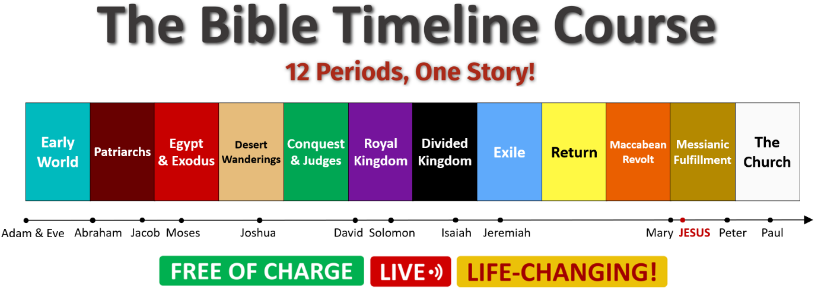

Starts: **Wed 7th April 2021** (7pm-8:30pm)

(for 8 consecutive Wednesdays)

 Info & Registration:

[**comeandsee.org/bt-register**](http://www.comeandsee.org/bt-register)

Still undecided?

[**Read over 270 Testimonials**](https://comeandsee.org/testimonials.html)

of some of the participants to Mauro's courses.

**Course Presentation**

[[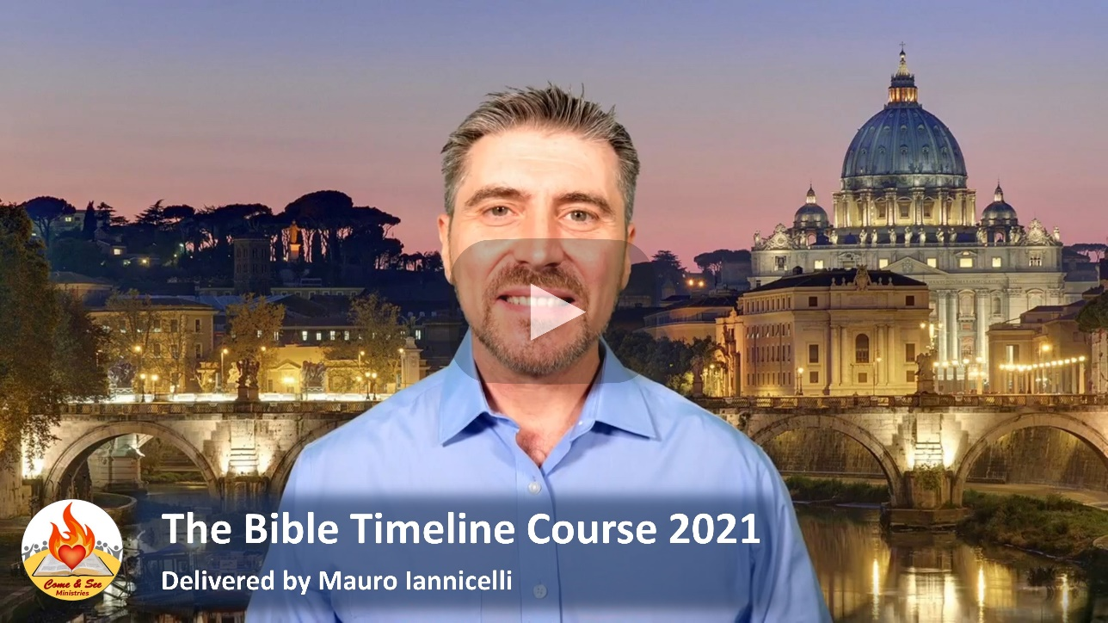](https://youtu.be/JtD0rjJW45k)](https://youtu.be/JtD0rjJW45k)

**COURSE SESSIONS**

Session 1 - Wed 07/04/2021 | 7-8:40pm  
Session 2  - Wed 14/04/2021 | 7-8:40pm  
Session 3 - Wed 21/04/2021 | 7-8:40pm  
Session 4 - Wed  28/04/2021 | 7-8:40pm  
Session 5 - Wed  05/05/2021 | 7-8:40pm  
Session 6 - Wed 12/05/2021 | 7-8:40pm  
Session 7 - Wed 19/05/2021 | 7-8:40pm

Session 8 - Wed 26/05/2021 | 7-8:40pm

[Watch Jeff Cavins' Endorsement](https://youtu.be/si-bIexBR74)

for Mauro as Bible Timeline Teacher for the UK.

[Watch Fr Alexander Sherbrooke's Testimony](https://youtu.be/RHbK0BH1TaE)

 about how Mauro ran two Bible Timeline Courses in his parish.

What is the Bible Timeline Course?

The Bible can be **quite intimidating**, due to its size and complexity.

Many Catholics long to read the Bible, but they don’t know **how**.

The Bible Timeline Study System, developed by Jeff Cavins, uses a **phenomenal approach** which actually works!

It divides the whole Bible into 12 colour-coded Periods, easy to understand and memorise.

In our course, Mauro will walk you through **each of the 12 Periods**. This way, you will clearly see how the many characters and events in Scripture are related to each other in one unified narrative, from Adam & Eve to Jesus Christ.

You will grasp the **Big Picture of the Bible** from start to finish, the Old and New Testament, ...for life!

Each live-streamed session has a time of discussion with Q&A.

Bible Readings and Teaching Summary Notes will be available.

*Mauro Iannicelli*

*(Come & See Catholic Evangelisation Ministries)*

