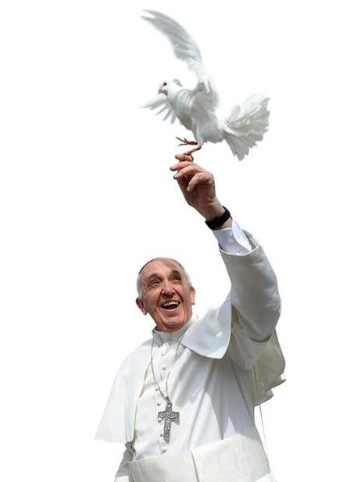

What are St James’ doing right as a parish?
What are we doing wrong?
What can we do better?

You are cordially invited to join us to discuss these questions and how we as a parish can make the vision of Pope Francis as laid out in Evangelii Gaudium (The Joy of the Gospel) a reality in Petts Wood.
‘At the heart of the Gospel is life in community and engagement with others’ EG177

RSVP to the Parish Office indicating whether you wish to attend physically or via Facebook Live

Fr. David and the Evangelisation Team

