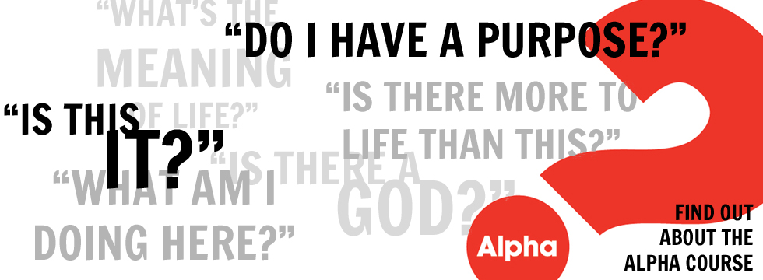

**ST JAMES THE GREAT ALPHA COURSE**

Course starting 20th September 2022

Come and meet the team in the Community Centre, after the 11AM Mass, on Sunday 11th September to find out more about the course.

To register, contact the Parish Office on: parish.office@stjamespettswood.org